Pet Adoption

Daniel Pivonka, Brianne Bindas, and Scott Mello

# 1. Goal

* Connect users to a database of over 300,000 pets up for adoption
* Use our search feature to find your perfect pet
* View pet profiles and pictures
* Add pets to your favorites so you don’t lose track of the pet you want
* Help more pets get adopted!

# 2. Features

* Pet Search Functionality
* Display list of pets that match search
* View pet profile and pictures
* Favorites database to store pets your thinking of adopting

# 3. Project Design

To use the pet adoption app, the user starts at the main activity. They enter their location here. They could also go directly to the favorites activity. After the main activity the user will continue the pet type activity. Here they will select what type of pet they want. After this they will be sent to the pet list activity, where they are shown the list of pets that match their search. Then they can select a single pet and they will be brought to the pet view activity where they are shown the pet profile. At the pet list activity and the pet view activity the user can go to the favorites activity. The favorites activity shows a list of favorited pets. The user can select to view one pet from that list and they will be brought the favorite view activity.

FavoritesActivity

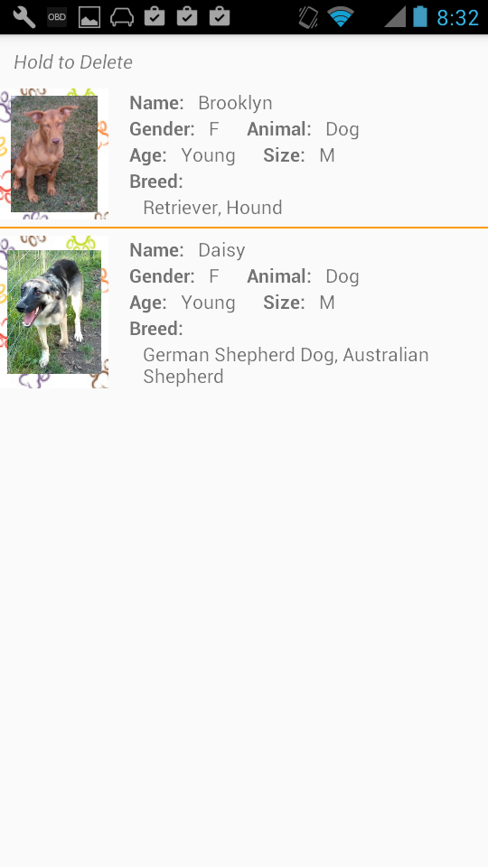

FavoritesViewActivity

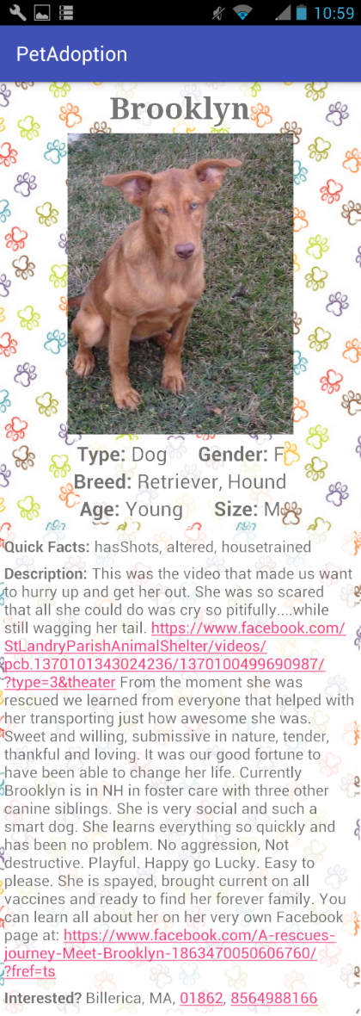

MainActivity

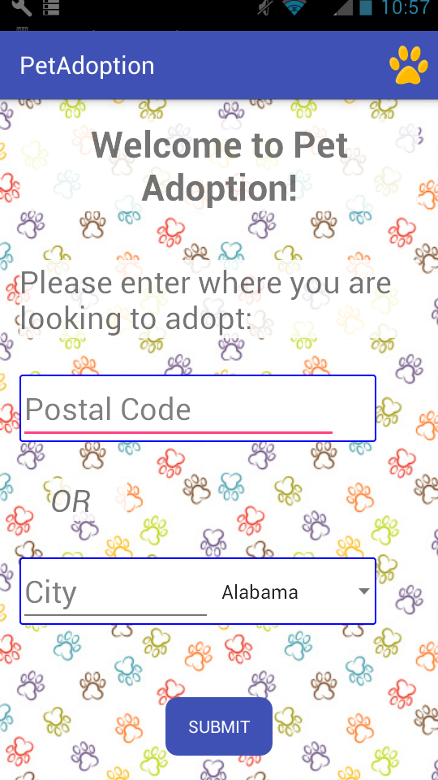

PetTypeActivity

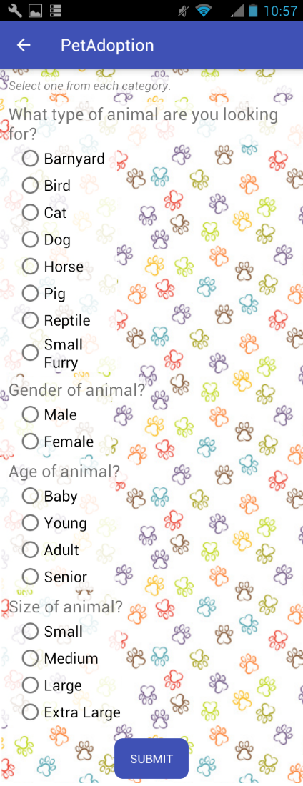

PetViewActivity

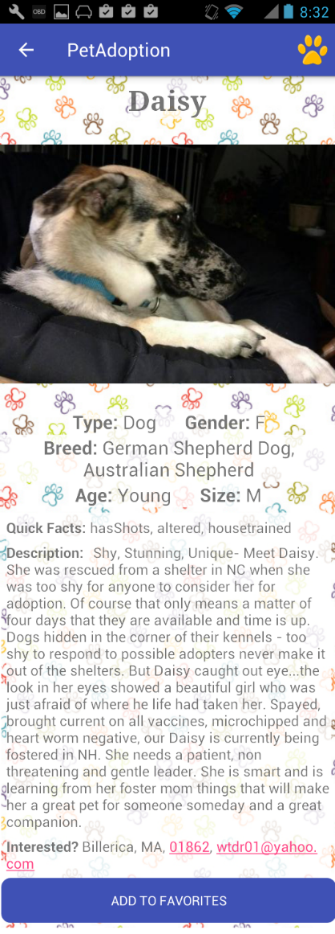

PetListActivity

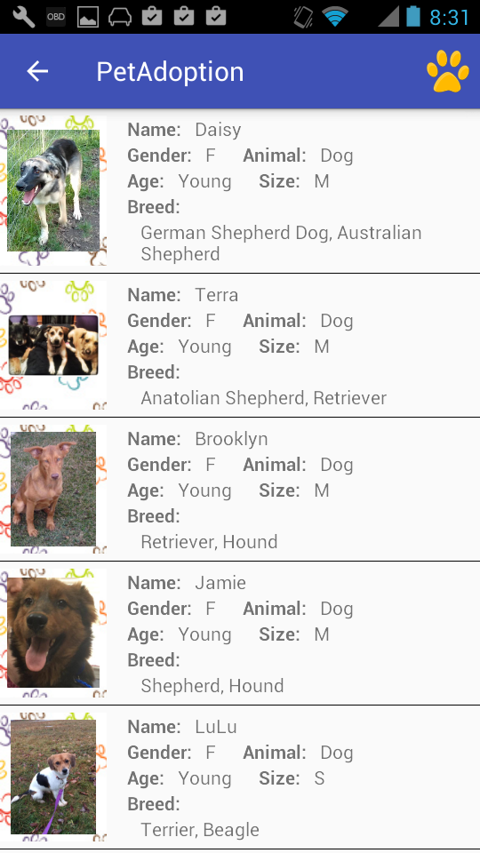

# 4. File Structure

* MainActivity – Gets location from user – Code by Daniel, Layout by Brianne
* PetTypeActivity – Gets search options from user – Code by Daniel and Brianne, Layout by Brianne
* PetListActivity – Show list of pet returned from search, starts AsyncTask – Code by Daniel, Layout by Brianne
* PetViewActivity –Show profile and pictures of selected pet – Code By Daniel and Brianne, Layout by Brianne
* FavoritesActivity – Show list of pets added to favorites – Code by Scott, Layout by Scott and Brianne
* FavoritesViewActivity- Shows profile and picture of pet from favorites list – Code by Scott, Layout by Brianne
* Pets – Class to hold a single pets info – Code by Daniel
* PetAdapter – Adapter used to display pet list – Code by Daniel
* FavoritesTable – Database to hold favorite pets info – Code by Scott
* FavoritesContentProvider - Manages access to the Favorites Database - Code by Scott
* PetAdoptionDatabaseHelper - A helper class to manage database creation/version - Code by Scott
* PetCursorAdapter - Used to bind database fields to views - Code by ScottUtils – Network utilities to retrieve pets from API – Code by Daniel